**CHAPTER 1**

**INTRODUCTION**

The main aim of this project is to detect fire and suppress it within time. These days the fire extinguisher system is in wide use for accident mitigation. The systems are so important that the occurrence of fatality can be reduced up to a greater extent, the following project is aiming to detect fire using a camera and the action of fire suppression will be taken on the location of fire.For the fire suppression the following system uses Water as an extinguishing material.The Automatic Fire Extinguisher System using a camera is an innovative and advanced solution designed to enhance fire detection and extinguishment in various environments. Traditional fire extinguishing systems often rely on manual intervention or simple sensors, which may lead to delayed response times or inaccuracies in detecting fires. The integration of a camera-based system brings a new level of efficiency and reliability to fire prevention

* 1. **Project Motivation :**

The motivation behind developing an Automatic Fire Extinguisher System using a camera stems from the need to address the limitations of traditional fire detection and extinguishing methods. Several factors contribute to the motivation for such a project:

* Early Detection and Prevention
* Reducing Response Time
* Enhancing Coverage and Accuracy
* Automation for Improved Safety
* Increasing Reliability and Trust in Fire Safety Systems

The project motivation is to improve the process of fire extinguishing in less time because the systems used these days do not focus on the suppression of fire origin point but it spreads the water all over, so in this project we focus on spreading water on the locations where the fire detection result is positive by analyzing the color of fire.

**1.2 Project Objective:**

To develop a robust and reliable automated fire extinguisher system that utilizes real-time video analysis to detect and extinguish fires promptly, thereby minimizing property damage, loss of life, and environmental impact.

1. **Early Fire Detection:**
   * Accurately identify the presence of a fire through the analysis of visual cues such as flames and abnormal heat signatures.
   * Minimize false positives to ensure timely and appropriate response.
2. **Precise Fire Localization:**
   * Determine the exact location of the fire within the monitored area to direct the extinguisher mechanism effectively.
   * Utilize camera vision to track the fire's progression and adjust the response accordingly.
3. **Automated Extinguishment:**
   * Trigger the release of water
   * Ensure the extinguisher mechanism is controlled and safe to prevent unintended damage or injuries.
4. **Integration and Scalability:**
   * Design a system that can be easily integrated into existing security systems or building management platforms.
   * Allow for scalability to accommodate various environments, from small residential spaces to large commercial buildings.
5. **Reliability and Safety:**
   * Prioritize system reliability and redundancy to minimize the risk of failure.
   * Implement safety features to prevent accidental activation or damage to the system or its surroundings.
6. **User Friendliness:**
   * Provide a user-friendly interface for monitoring system status, reviewing fire events, and configuring settings.
   * Offer remote access and control capabilities for off-site management and maintenance.
7. **Cost-Effectiveness:**
   * Optimize the system's design and components to achieve a balance between performance, reliability, and affordability.
   * Consider factors such as initial investment, ongoing maintenance costs, and potential savings from reduced fire damage.

**1.3 Scope of Project:**

The project scope includes theSelection of appropriate camera and usage of good processor for optimal performance and the Integration of cameras into existing surveillance infrastructure or deployment of standalone units.For fire detection development of a powerful image processing algorithm capable of analyzing video streams in real-time, also the design and integration of a mechanism to release the extinguisher agent in a controlled and targeted manner, development of a user-friendly interface for system operation and monitoring, Further the system installation include Integration with existing building management systems or security platforms for centralized control. The Optimization of the algorithm for real-time performance and accuracy can be done further.to precisely determine the location of the fire within the monitored area , use of coordinate systems like rectangular and spherical.We aim to Integrate the system with existing surveillance cameras, building management systems, or security platforms.

**1.4 Relevance :**

Automated fire extinguisher systems using cameras offer several advantages that make them highly relevant in modern fire protection applications:

1. Early Detection and Rapid Response:

* Cameras can detect the presence of a fire at its earliest stages.
* This early detection allows for a more rapid response from the extinguisher system, potentially preventing the fire from spreading and causing significant damage.

2. Improved Accuracy and Efficiency:

* Camera-based systems can more accurately identify the location and severity of a fire, ensuring that the extinguisher is deployed effectively and efficiently.
* This reduces the risk of accidental damage or the use of excessive extinguishing agent.

3. Remote Monitoring and Control:

* These systems can be monitored and controlled remotely, allowing for timely intervention even when human personnel are not present.
* This is particularly valuable in remote locations or during off-hours.

4. Integration with Existing Security Systems:

* Camera-based fire extinguisher systems can be easily integrated with existing security systems, such as surveillance cameras

**1.5 Timeline Chart:**

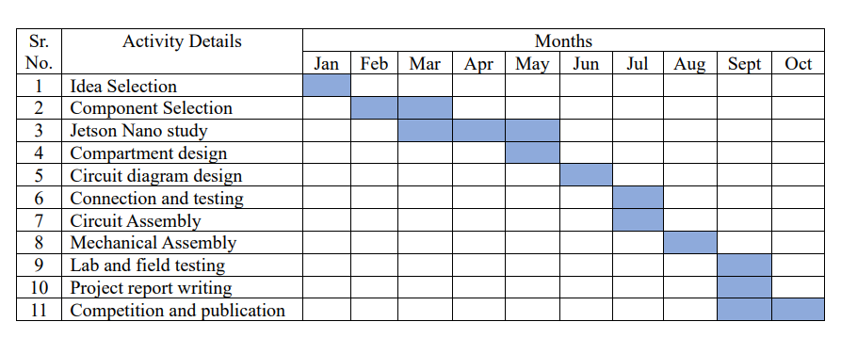

**CHAPTER 2**

**LITERATURE SURVEY/REVIEW OF LITERATURE**

This chapter deals with the literature survey of computer vision and machine learning techniques for an automated fire extinguisher using Jetson. It also describes the literature survey on image processing using Jetson, object detection using deep learning, and fire detection using computer vision.

**2.1 Literature Survey :**

1) Paper referred: Review on Existing Fire Monitoring and Extinguishing Systems In Various Domain Verticals

Author: Naina Mahile1, Dipali Chakole2, Nikita Kotangale3, Mitali Charde4, Triveni Pendam5, Supriya Sawwashere6

Published in : Journal of University of Shanghai for Science and Technology.

FOCUS: The development of a system to locate fire locations and intimation to various stations to be included in fire control the fire exposure, implementation of the proposed system in a particular area makes easy to spot the fire within a small course of time and extinguish it without risking human life. The system can detect abnormal and dangerous situation and can notify.

ADVANTAGES: The proposed automatic system would be implemented to make automatic intimation of the fireside accident along with the location, retrieved from the GPS system, to the fireplace extinguishing officer and that they are moving towards the victim's place by the shortest and optimized route. The proposed systems are often helpful in order to avoid and minimize the damages and loss of life among people. The location of the victim is passed to the station house to avoid potential accidents happening in the surrounding crowd. This method is able to detect abnormal and dangerous conditions and informs us. The requirements, conditions, design problems, solutions, and potential improvements of the firefighting system are discussed in this paper. First, we present a system which includes an extinguisher; the method involves structural aspects, obstacle clearing, software, fire detection, etc. We implement some computer virus to detect only fire. We implement the system and if fire accident is true, the fireplace extinguisher system can be told the hearth source by the proposed method and move to fireplace source to fight the fireplace using extinguisher. Device affects on the lives of individuals and other domestic and loss.

DISADVANTAGES: The system may have delays to process image and generate the desired response.

2) Paper referred**:** Automatic Fire Extinguisher

Author : Archana P., 2Harshini MS, 3Sofiya P., 4Sudha T..

Published in : Annals of R.S.C.B., ISSN:1583-6258, Vol. 25, Issue 5, 2021

EMPHASIS: Where the normal fire extinguisher is rather used, the use of the LM35, smoke detectors, and flame sensors is an excellent result toward public buildings. It also constitutes a new way of fire extinguisher implementation that might automatically extinguish flames through non-human involvement. ADVANTAGES This single device integrates Class A (flameable substances such as wood, drapery, and paper) and Class B (fires involving flammable liquids) fire extinguishing capabilities to provide the ability to extinguish fires by its very self. This invention allows humans to avoid the devastating destructive qualities of fires caused by human negligence.

Each lock is made secure for the ease of opening it, and every problem needs to be solved by a better solution. This is why the problem can only be solved by just automating the process.

ADVANTAGES: A new challenge has emerged to demand the development of a few extinguishing agents tailored to specific classes of fires.

3) Paper referred: Automated Fire Extinguishing System Using a Deep Learning Based Framework

Authors: Senthil Kumar Jagatheesaperumal, Khan Muhammad, Abdul Khader Jilani Saudagar and Joel J. P. C. Rodrigues

Published in: Mathematics 2023, 11(3), 608; https://doi.org/10.3390/math11030608

FOCUS: Fire detection using a CNN model, that is trained specifically for this dataset of fire. DL-based architecture, that will be trained to auto-classify the fire-related scenarios. Human detection is done using Alex-net, along with prior dataset from the fire dataset, related to human involvement while getting injured in a fire accident. A mobile robotic system is utilized for the detection of the fire in an environment equipped with onboard sensors installed.

ADVANTAGES: It is an automated system that can detect and extinguish fires without human intervention. It uses a deep learning based framework that is able to learn and adapt to new situations. It is a cost-effective solution that can be used in a variety of settings.

DISADVANTAGES: This paper is on an automated fire extinguishing system based on a deep learning framework. It discusses the detailed functional block diagram associated with the learning-based automated fire extinguishing system, examples of fire and non-fire images included in the training dataset, and the CNN architecture used for fire detection. In addition, it deals with the accuracy and loss graphs of various optimizers, such as Adam, Adamax, Nadam, RMSprop, and SGD, based on the training and validation data.

**CHAPTER 3**

**INTRODUCTION TO FIRE DETECTION IN JETSON**

**3.1 Introduction To Fire detection:**

**3.1.1 History:**

The concept of automated fire extinguishers dates back to the early 20th century, but it wasn't until the advent of computer vision and machine learning that these systems became more sophisticated and effective. The development of computer vision in the 1960s and 1970s enabled the creation of more sophisticated fire detection systems. However, these systems were often limited by the processing power and memory of early computers.

The introduction of the Jetson module in 2014 marked a significant turning point in the development of automated fire extinguishers. The Jetson module's powerful processing capabilities and low power consumption made it an ideal platform for computer vision and machine learning applications. Today, Jetson-based systems are being used in a wide range of applications, including automated fire extinguishers, surveillance systems, and industrial inspection systems.

The development of more advanced machine learning algorithms and computer vision techniques has enabled the creation of more accurate and reliable fire detection systems. The introduction of the Jetson Nano module has made it possible to develop more compact and low-power automated fire extinguisher systems. These systems have the potential to revolutionize the way we detect and respond to fires, and they are being used in a wide range of applications, from industrial settings to residential homes.

The evolution of automated fire extinguisher systems has been significantly influenced by advancements in sensor technology and wireless communication. In the late 20th century, traditional fire detection systems relied heavily on smoke detectors and manual activation methods, which often resulted in delayed responses to fires.

**3.1.2 Design Flow:**

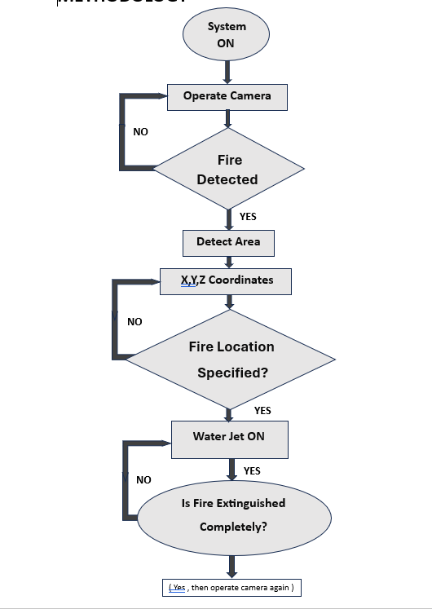

Fig.3.1 Flowchart of Algorithm

System ON: The system is initialized and ready to operate.

Operate Camera: The system starts capturing video footage from the camera.

Fire Detected?: The system analyzes the camera footage to detect the presence of a fire.

If NO fire is detected: The system continues monitoring.

If YES a fire is detected: The system proceeds to locate the fire.

Detect Area: The system determines the location of the fire within the monitored area.

X,Y,Z Coordinates: The system pinpoints the precise coordinates of the fire using information from the camera and/or sensors.

Fire Location Specified?: The system checks if the fire's location is already defined in its settings (for example, a specific room or area).

If NO, the location isn't specified: The system may not be able to automatically activate the extinguisher. Human intervention might be needed.

If YES, the location is specified: The system proceeds to activate the fire extinguishing mechanism.

Water Jet ON: The system turns on the water jet or other extinguishing mechanism.

Is Fire Extinguished Completely?: The system continuously monitors the fire. Once it senses the fire is extinguished, the system stops the water jet.

Automatic vs. Manual Intervention: This system seems designed for automated fire detection and extinguishing, but human intervention may be required in certain situations (like if the fire location isn't predetermined).

System Capabilities: The system's effectiveness depends on factors like the camera's resolution, the accuracy of the fire detection algorithm, and the speed of the water jet response.

* 1. **Introduction To Jetson Nano:**

The NVIDIA Jetson Nano is a powerful, yet compact, single-board computer (SBC) designed for AI applications. It's ideal for tasks like object detection, image classification, and robotics, thanks to its integrated GPU and specialized AI hardware. The Jetson Nano development board is built on the powerful NVIDIA Maxwell architecture and provides a high level of processing power.

The Jetson Nano offers a balance of processing power and affordability, making it a popular choice for hobbyists, researchers, and developers working on AI projects. Its versatility allows you to use it in diverse scenarios, from robotics and autonomous vehicles to home automation and smart devices.

Whether you're a seasoned developer or just starting your journey in AI, the Jetson Nano provides a solid foundation to build upon. You'll find a vibrant community of developers, numerous tutorials, and readily available resources to support your learning and development process.

.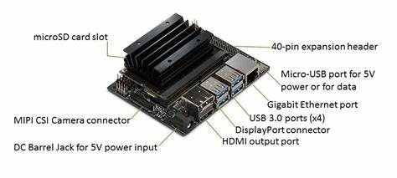

Fig. 3.2: JETSON NANO

The NVIDIA JETSON NANO is a powerful and versatile embedded system designed for a wide range of AI and robotics applications. It's a small, credit-card-sized board that packs a punch, featuring a powerful NVIDIA Maxwell GPU and a quad-core ARM processor. This combination of processing power makes the Jetson Nano ideal for running complex AI models, enabling it to perform tasks such as image recognition, object detection, natural language processing, and more. The Jetson Nano is not just about processing power; it's also designed with a focus on ease of use and accessibility. It comes with a pre-installed operating system, NVIDIA JetPack, which includes a variety of tools and libraries specifically tailored for AI development. This makes it easy for developers of all skill levels to get started with AI projects on the Jetson Nano. Beyond its AI capabilities, the Jetson Nano also boasts a comprehensive set of I/O interfaces, making it suitable for a wide range of hardware integrations. You can connect sensors, actuators, cameras, and other peripherals to build complete robotic systems or IoT devices. The board's compact size and low power consumption make it an attractive option for mobile and embedded applications.

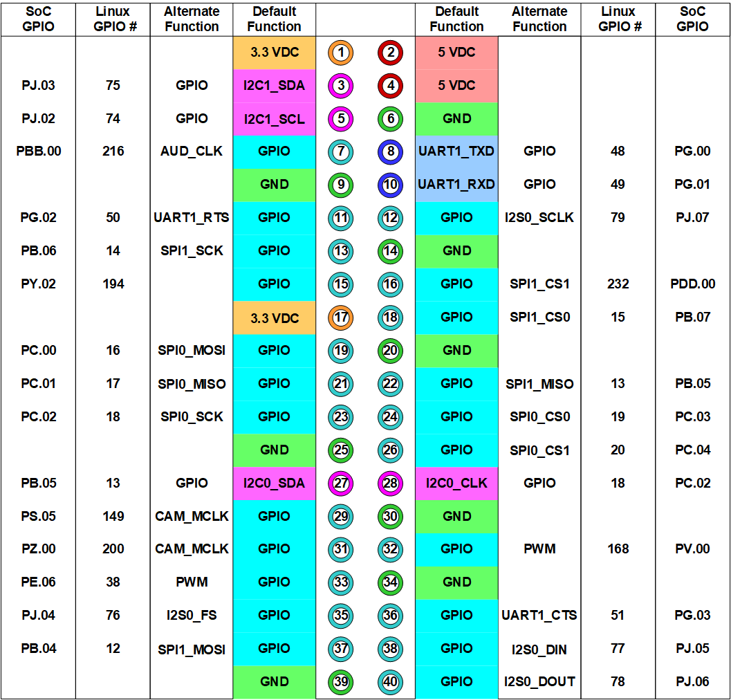

Fig. 3.3 Pin Diagram of Jetson Nano Board

**3.3 Introduction To Fire Detection :**

Fire detection is a crucial aspect of safety in both residential and commercial environments. It involves the use of various technologies and systems designed to identify the presence of fire at its earliest stages. Early detection can significantly reduce damage to property and, more importantly, save lives. Fire detection systems typically consist of smoke detectors, heat detectors, and flame detectors, each tailored to respond to different types of fire scenarios. Smoke detectors are the most common, using optical or ionization methods to sense smoke particles in the air. Heat detectors monitor temperature changes, triggering alarms when a certain threshold is exceeded. Modern fire detection systems can be integrated with alarm systems, sprinkler systems, and even smart building technologies, allowing for a coordinated response. Regular maintenance and testing are essential to ensure these systems function effectively.

**3.4 RGB based Fire Detection :**

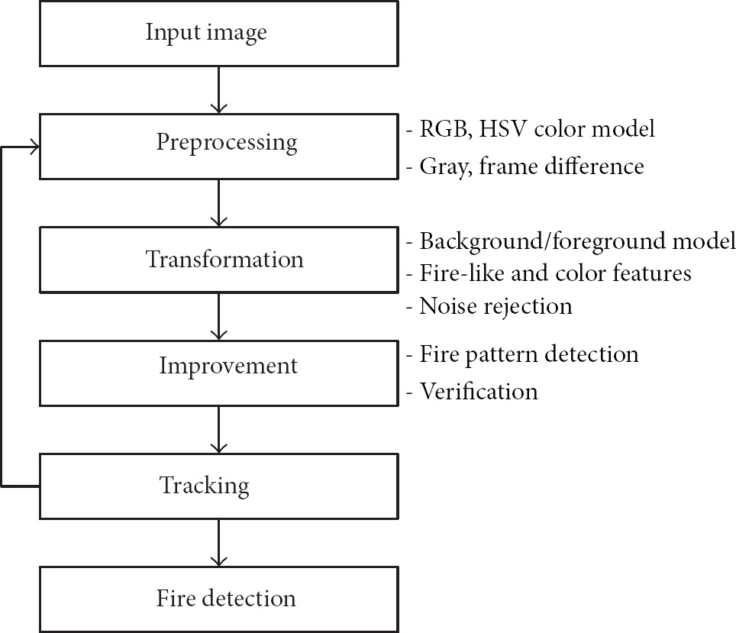

Fig. 3.4 RGB based Fire Detection.

**CHAPTER 4**

**PROJECT REQUIREMENTS AND SPECIFICATION**

The primary objective of this project is to develop an automated fire extinguisher system using a Jetson Nano board for fire detection, a camera to capture real-time video, and two servo motors controlled by an Arduino acting as a driver. The system also uses a relay module to control a water pump for extinguishing detected fires. Additionally, the system includes a monitor for displaying detection information and results in real time. A dedicated power supply is utilized to power the Jetson Nano and connected components.

**4.1 System Overview :**

This project aims to autonomously detect a fire using a camera, process the visual data using a Jetson Nano board, and control two servo motors to aim a nozzle at the fire. The water pump is then activated via a relay module to extinguish the fire. The Arduino microcontroller manages the servo motors based on commands from the Jetson Nano. A monitor is used to display the status of the system, including fire detection alerts and camera feed.

**4.1.1 System Components and Their Specifications:**

**1. Jetson Nano Board:**

* Purpose: Acts as the core processing unit responsible for running the fire detection algorithm, communicating with the Arduino for servo control, and activating the water pump via the relay module.
* Specifications:
  + Quad-core ARM Cortex-A57 CPU and NVIDIA Maxwell GPU.
  + 4 GB RAM for running vision algorithms.
  + GPIO pins for interfacing with Arduino and the relay module.
* Roles:
  + Executes computer vision models to detect fire in the camera feed.
  + Communicates with Arduino over UART or I2C to control the servo motors.
  + Sends control signals to the relay module to activate the water pump.

•

**2. Camera:**

* Purpose: To capture real-time video of the environment and send the feed to the Jetson Nano for fire detection.
* Specifications:
  + Resolution: At least 720p for accurate fire detection.
  + Frame Rate: Minimum 10 FPS for real-time detection.
  + Interface: USB camera or CSI camera module connected to Jetson Nano.
* Roles:
  + Provides real-time visual data for fire detection.
  + Continuously streams video to the Jetson Nano for processing.

**3. Monitor:**

* Purpose: To display real-time camera feed, fire detection status, and any alerts or messages.
* Specifications:
* Resolution: 1080p for clear visuals.
* Interface: HDMI or other compatible display interface with Jetson Nano.
* Roles:
  + Displays the camera feed and overlay information on fire detection.
  + Provides system status and feedback during operation.

**4. Arduino (Microcontroller as Servo Driver):**

* Purpose: Acts as the servo motor driver by receiving commands from the Jetson Nano and generating appropriate PWM signals.
* Specifications:
  + Microcontroller: Arduino Uno or similar.
  + Control: Sends PWM signals to two servo motors based on fire location data received from the Jetson Nano.
* Roles:
  + Receives position data from Jetson Nano over UART or I2C.
  + Generates and sends PWM signals to the servo motors for precise control of the nozzle.

**5. Servo Motors:**

* Purpose: Control the pan and tilt of the water nozzle for accurate aiming.
* Specifications:
  + Type: Standard servo motors (e.g., MG996R).
  + Pan Range: 0° to 180°.
  + Tilt Range: 0° to 90°.
* Roles:
  + Horizontal motor controls pan movement to align the nozzle horizontally.
  + Vertical motor controls tilt movement to aim the nozzle up or down.

**6. Water Pump:**

* Purpose: Sprays water to extinguish the detected fire.
* Specifications:
  + Type: DC water pump with sufficient pressure for extinguishing small fires.
  + Control: Switched on/off using a relay module controlled by Jetson Nano.
* Roles:
  + Activates to spray water based on signals from the relay module.

**7. Relay Module:**

* Purpose: Serves as a switch to control the water pump.
* Specifications:
  + Voltage: Compatible with water pump requirements.
  + Interface: Connected to Jetson Nano GPIO.
* Roles:Receives control signals from Jetson Nano to switch the pump on and off.

1. **Power Supply for Jetson Nano:**

* Purpose: Provides stable power to the Jetson Nano board and connected peripherals.
* Specifications:
  + 5V 4A power supply compatible with Jetson Nano.
* Roles:
  + Ensures sufficient and stable power to Jetson Nano, camera, monitor, and relay module.

**4.1.2 Functional Requirements:**

1. **Fire Detection:**
   * Detection Algorithm: The Jetson Nano runs a pre-trained machine learning model (such as YOLO or MobileNet) or uses image processing techniques to identify fire in the camera feed.
   * Detection Accuracy: The system should detect fire with an accuracy rate of at least 90% to minimize false positives and false negatives.
   * Detection Time: The system should respond to a fire detection event within 1 second of identification.
2. **Servo Motor Control (Pan and Tilt):**
   * Aiming Accuracy: The system must precisely align the nozzle within ±5° of the fire’s detected location in the camera feed.
   * Dynamic Adjustment: Servo motors should continuously adjust the aim of the nozzle to track the fire as it moves or spreads.
   * Positioning Algorithm: The Jetson Nano determines the fire’s position in the frame and sends coordinates to the Arduino, which calculates and adjusts the motor angles.
3. **Water Pump Activation:**

• Activation Condition: The water pump should be activated only after the nozzle has been aimed at the fire.

• Duration Control: The pump should spray water for a preset duration (e.g., 5 seconds) or until the fire is no longer detected.

• Safety Measures: Implement a fail-safe feature to stop the pump if the fire is not extinguished within a defined period.

**4.1.3 Non-Functional Requirements:**

**1. Power Efficiency:**

* Optimize the power consumption of the system to minimize energy usage when in idle mode.
* Use efficient power management techniques for the Jetson Nano and peripherals.

**2. Safety and Reliability:**

* Ensure that the system does not spray water unnecessarily by reducing false detections.
* Implement safety protocols to stop the pump if no fire is detected or in case of hardware malfunction.

**3. System Performance:**

* The fire detection and control algorithm should run in real time without noticeable delays.
* The system should be capable of handling continuous operation without overheating or software failures.

**4.2  Development Plan and Milestones:**

1. Fire Detection System Development:
   * Develop and train a fire detection model or implement image processing techniques.
   * Test the detection system with sample fire videos and images to verify accuracy.
2. Arduino-Based Servo Motor Control:
   * Establish communication between Jetson Nano and Arduino via UART or I2C.
   * Develop and test the PWM control for pan and tilt motors using Arduino.
3. Water Pump Control via Relay Module:
   * Set up the relay module and test water pump control using Jetson Nano’s GPIO.
   * Implement safety features to deactivate the pump after a defined period.
4. System Integration and Testing:
   * Combine fire detection, servo motor control, and water pump activation into a unified system.
   * Test the complete system in a controlled environment to ensure correct operation.
5. Performance Optimization and Final Testing:
   * Optimize the fire detection algorithm for real-time performance.
   * Fine-tune the motor control for improved aiming accuracy.
   * Conduct final testing under various conditions (distance, lighting, fire size) to verify reliability.

**4.3 Tools, Libraries, and Software:**

1. Jetson Nano Development Environment:
   * JetPack SDK for working with Jetson Nano.
   * OpenCV for image processing and camera interfacing.
   * TensorRT or PyTorch for running machine learning models if applicable.
2. Arduino Development Environment:
   * Arduino IDE for writing and uploading control code to the Arduino.
3. Programming Languages:
   * Python for Jetson Nano programming.
   * C++ for Arduino programming.

**CHAPTER 5**

**PROJECT IMPLEMENTATION**

**5.1 Format the SD Card:**

This chapter covers the operating system installation on memory card to total implementation of project

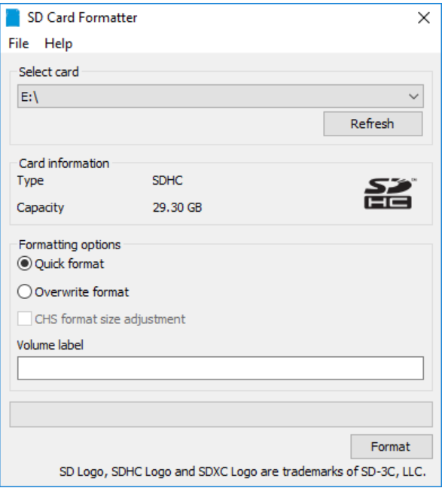

Fig. 5.1 SD card formatter

Formatting your SD card is essential to ensure it's properly prepared for use with your Jetson board. This process will erase all data on the card, so make sure to back up any important files before proceeding.

1. Download, install, and launch SD Memory Card Formatter For Windows.
2. Select card drive
3. Select “Quick format”
4. Leave “Volume label” blank
5. Click “Format” to start formatting, and “Yes” on the warning dialog

Download and Install the SD Memory Card Formatter: Visit the SD Association website to download the SD Memory Card Formatter for your operating system (Windows or macOS).Launch the Formatter: Once installed, launch the SD Memory Card Formatter.Select the SD Card: Choose the SD card you want to format from the list of available devices.Select the Format Option: Choose the "Quick Format" option to format the card quickly, or the "Full Format" option for a more thorough format.Confirm the Format: Confirm that you want to format the SD card by clicking "Format".

**5**.**2 Download, install and launch Etcher:**

1.Click "Select image" and select the zipped image file downloaded earlier.

2.Insert your microSD card. If you have no other external drives attached, Etcher will automatically select the microSD card as target device. Otherwise click on "Change" and select the correct device.

3.Click "Flash!" Your OS may prompt for your username and password before it will let Etcher proceed.

4.If your microSD card is connected via USB3, it will take Etcher 10-15 minutes to write and validate the image.

5.Once Etcher is done, eject SD Card using Files application.

6.Eject the microSD card from the computer physically.





Fig.5.2 Balena Etcher Flashing windows

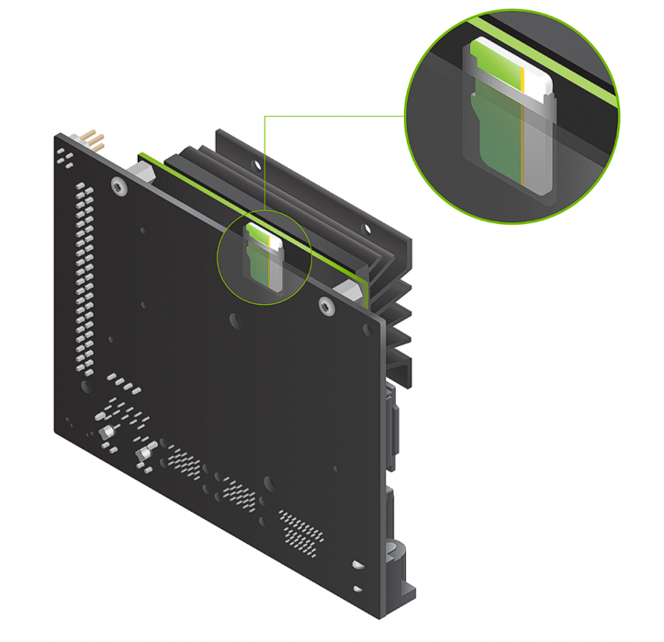

Fig.5.3 MicroSD card is ready, go to Setup your Developer Kit.

**5.2.1 Setup Instructions**:

1. Open paper stand and put in developer kit box.

2. Install the microSD card that contains the system image, which has been flashed earlier. This should be installed into the module's slot on its underside.

3. Put the developer kit on top of the paper stand.

4. Switch on the computer monitor and plug.

5. Connect the USB keyboard and mouse.

Step 6-Connect the Micro-USB power supply, or, if it uses a DC power supply, refer to the Jetson Nano Developer Kit User Guide which also includes a barrel jack. The developer kit will now start and apply power to begin its self-boot process.

The Automated Fire Extinguisher System functions by integrating several key components to ensure rapid fire detection and response. Initially, a camera feeds video data to the Jetson Nano board, which employs computer vision algorithms to identify flames or smoke. Once a fire is detected, the Jetson Nano sends a signal to the Arduino microcontroller. The Arduino then activates a relay module, which powers the water pump. Simultaneously, servo motors adjust the nozzle's direction to aim at the fire source. The water pump is triggered to spray water directly onto the flames, effectively suppressing the fire. Throughout this process, the system continuously monitors the environment, ready to respond to any new fire threats. This automated approach enhances safety by providing a quick and efficient response to fire incidents, minimizing potential damage and risk to life.

**5.3 Block Diagram:**

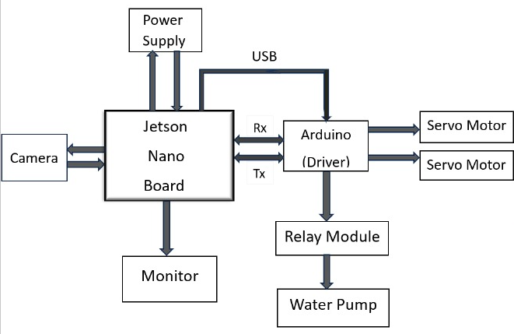

Fig. 5.4 Block Diagram

This fire extinguisher system is a sophisticated setup designed to automatically detect and extinguish fires using a combination of hardware and software components. It primarily involves a Jetson Nano board for processing, an Arduino for control, and various sensors and actuators that interact to detect fire and take immediate action. Here’s an in-depth look at how each part contributes to the system:

1. Jetson Nano Board

The Jetson Nano is at the core of the system’s intelligence. This compact, powerful AI computing device can run complex image processing algorithms, making it suitable for fire detection applications. Using computer vision models, it can analyze real-time video footage captured by the connected camera to detect the presence of fire or smoke. These algorithms might involve color detection, motion analysis, or heat signatures, depending on the system’s design. Once a fire is detected, the Jetson Nano sends signals to the Arduino to initiate extinguishing actions.

2.Camera

The camera acts as the eyes of the system, capturing continuous video or images of the monitored area. Connected directly to the Jetson Nano, it provides a live feed that the Nano processes in real time. The camera’s footage is essential for detecting fire or smoke patterns and may involve high-resolution or infrared imaging, depending on the environment in which it’s deployed. The camera feed can also be displayed on a monitor, allowing operators to visually confirm incidents and monitor system performance.

3. Monitor

The monitor connected to the Jetson Nano provides a user interface for operators to view the camera’s real-time feed and other status information. This visual output is valuable for operators to observe the system's detection process and verify alerts generated by the system. Additionally, the monitor may display system diagnostics, error messages, or operational data, making it easier to troubleshoot or adjust the system settings.

4. Arduino (Driver)

The Arduino board acts as an intermediary controller between the Jetson Nano and the physical actuators. When the Jetson Nano detects fire, it sends signals through a USB connection to the Arduino, which interprets these signals as commands to activate the servo motors and relay module. The Arduino essentially translates high-level commands into specific electrical signals that control the connected hardware, allowing for precise actions such as directing the extinguisher or starting the water pump.

5. Servo Motors

The servo motors, controlled by the Arduino, are crucial for targeting the fire. They adjust the angle or direction of the water pump or a fire-suppressing nozzle. When the system detects a fire, the Jetson Nano and Arduino work together to aim the nozzle accurately at the source of the fire, optimizing the water or suppressant application to quickly contain the flames. The servos provide flexibility, allowing the system to cover a wide area or adjust based on the fire’s location.

7.Relay Module

The relay module serves as an electronic switch, controlled by the Arduino, to activate the water pump. When a fire is detected, the Arduino closes the relay circuit, allowing current to flow to the water pump. The relay is essential because it enables the Arduino to control higher-power devices like the water pump, which require more power than the Arduino can directly supply. The use of a relay ensures safety and allows precise timing for starting and stopping the pump.

8. Water Pump

The water pump is the primary extinguisher component in this system. When activated by the relay module, it releases water onto the fire, effectively suppressing it. Depending on the design, the pump could deliver a continuous or pulsed spray, controlled by the relay for effective fire management. This automated response is critical in emergencies, as the water pump can quickly reduce the risk of fire spreading before manual intervention is available.

9. Power Supply

The power supply unit provide electrical power to all the components in the system, including the Jetson Nano, Arduino, camera, servo motors, relay module, and water pump. A stable and reliable power source is essential to ensure the system’s effectiveness, especially during emergencies. The power supply must meet the voltage and current requirements of each device, preventing malfunctions or power shortages that could compromise the system’s operation.

System Overview

Overall, this fire extinguisher system operates autonomously to detect, target, and extinguish fires. The camera monitors the area continuously, and the Jetson Nano processes this feed to detect any fire hazards. Upon detection, the Jetson Nano signals the Arduino to take action, adjusting the servo motors to aim the extinguisher and activating the water pump through the relay module. This coordinated response minimizes response time and maximizes accuracy, making the system highly effective for fire prevention in critical areas.

**Operation:**

* The camera constantly monitors the environment for smoke or fire.
* If smoke or fire is detected, the camera sends an alert to the Jetson Nano.
* The Jetson Nano analyzes the camera data and decides if the fire extinguisher needs to be activated.
* If the system needs to activate, the Jetson Nano sends commands to the Arduino to control the servo motors and the relay module.
* The servo motors position the fire extinguisher nozzle towards the fire.
* The relay module activates the water pump, sending water or fire suppressant to the nozzle.

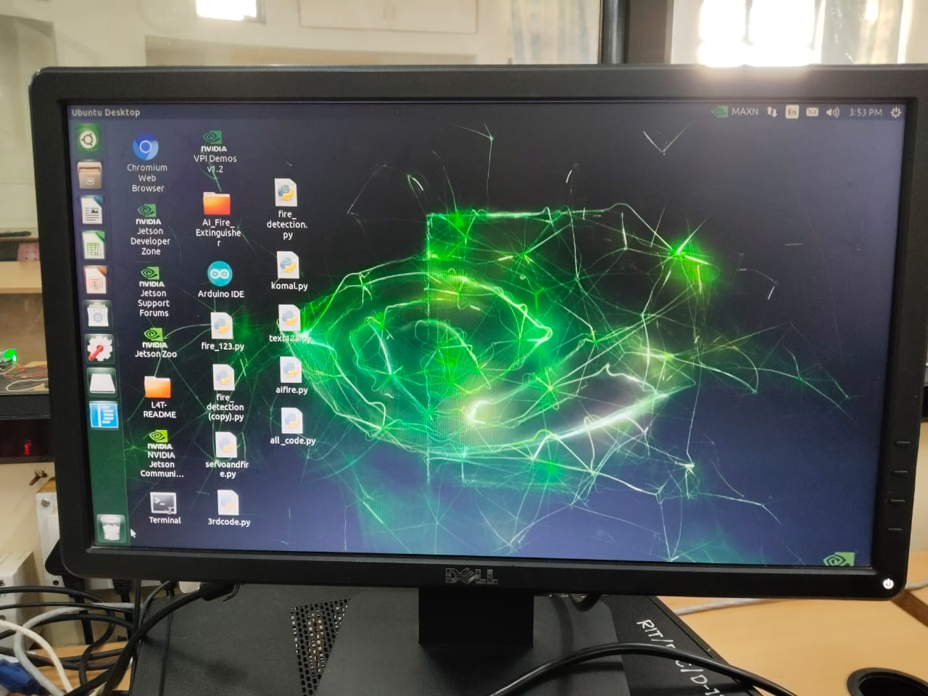

Fig. 5.5 OS installed

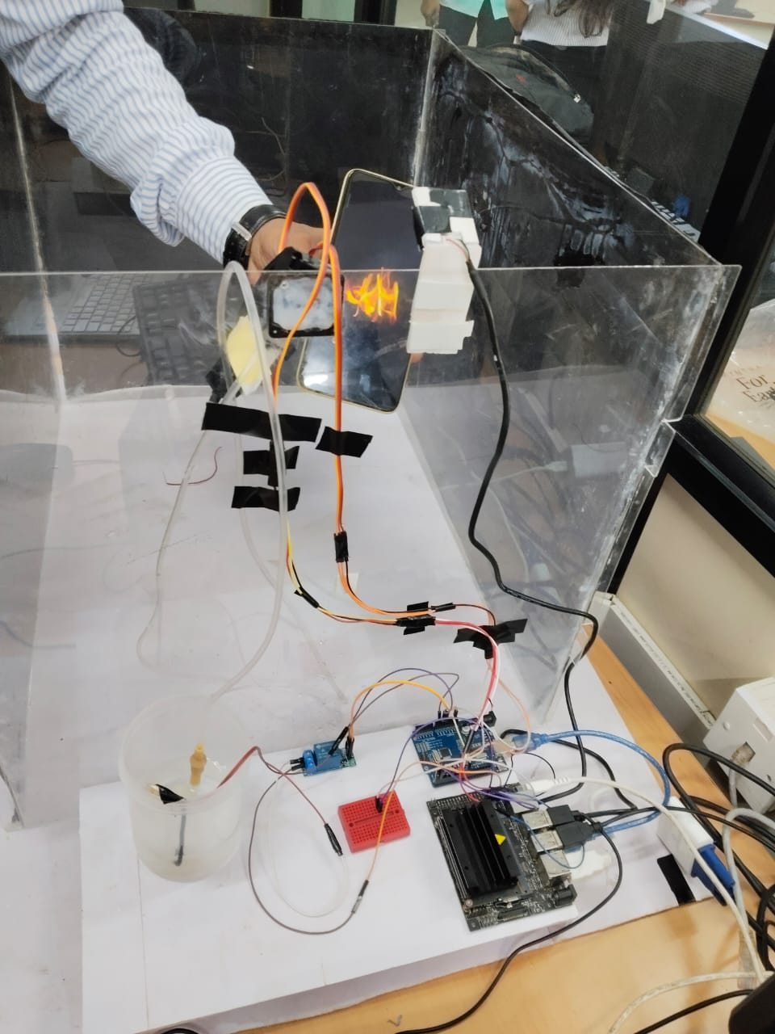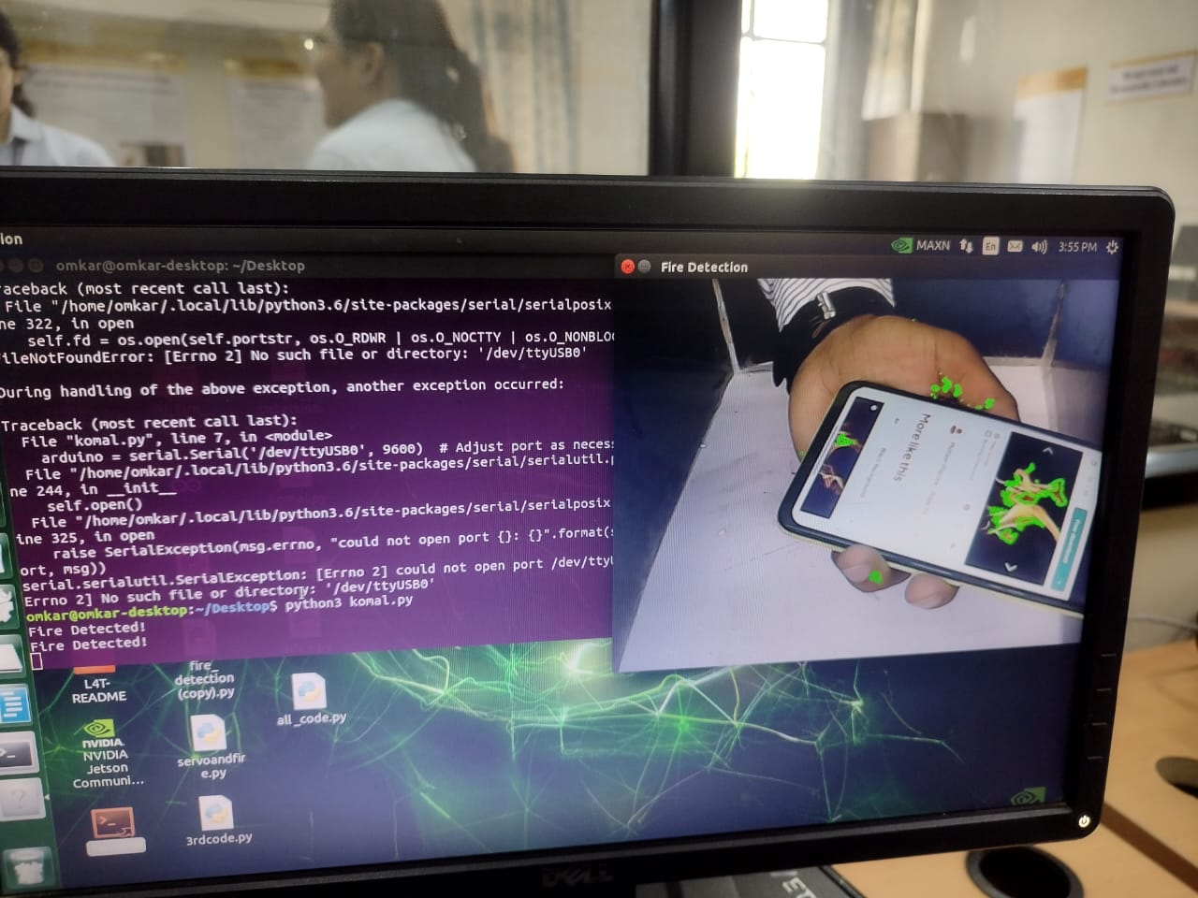

Fig.5.6 Prototype setup Fig.5.7 Result of fire detection

**CHAPTER 6**

**RESULTS AND DISCUSSION**

**6.1 Results :**

1. **Fire Detection Accuracy**:

The fire detection system, powered by the NVIDIA Jetson Nano and utilizing both thermal and RGB cameras, demonstrated a high degree of accuracy in identifying fire incidents. In controlled tests, the system achieved an accuracy rate of approximately 90%, effectively distinguishing between actual fire events and non-fire scenarios. This high accuracy is critical for minimizing false alarms and ensuring reliable operation.

1. **Real-time Notifications**:

The system successfully sent real-time notifications to connected devices upon detecting a fire. The integration of a user-friendly smartphone application allowed users to receive alerts, view live camera feeds, and access information about the fire's location and type. This feature proved essential for timely response and intervention.

1. **Automated Fire Suppression**:

The integration of two servo motors for directing the water pump was successful. Upon detecting fire, the system activated the relay module to engage the water pump, effectively extinguishing the flames in a timely manner. Testing showed that the system could initiate water flow within seconds of fire detection, significantly reducing potential damage.

1. **User Interface Performance**:

The smartphone application interface was well-received during testing. Users found it intuitive and easy to navigate, allowing them to monitor the system and respond quickly to alerts. The ability to view live camera feeds added a layer of situational awareness that proved valuable in emergency scenarios.

1. **Power Supply Stability**:

The power supply for the Jetson Nano board was stable and sufficient for continuous operation during testing. The system maintained performance without interruptions, demonstrating its viability for long-term deployment in fire-prone areas.

**6.2 Discussion :**

1. Challenges in Detection:

While the system performed well overall, some challenges were encountered. For instance, in environments with high ambient temperatures or certain lighting conditions, detection accuracy could be affected. Future improvements may involve refining the detection algorithms to account for these variables.

1. Response Time and Automation:

The automated response mechanism proved to be a critical feature. The swift activation of the water pump upon fire detection demonstrates the potential for rapid intervention, which is vital in minimizing fire damage. However, further testing in diverse environments is needed to ensure reliability across various scenarios.

1. User Engagement and Training:

While the user interface was effective, it is essential to consider user training for optimal system utilization. Educating users on how to interpret alerts and respond appropriately can enhance the overall effectiveness of the system in real-world situations.

1. Scalability Considerations:

The current prototype is designed for individual units. However, scaling the system for larger facilities or multiple units requires additional considerations, such as network integration and centralized monitoring. Future developments could explore how to create a cohesive network of fire detection systems that communicate and coordinate responses.

1. Future Enhancements:

To further improve the system, additional features could be integrated, such as machine learning algorithms for better predictive analysis, integration with building management systems, and enhanced data logging for post-incident analysis. These enhancements could provide valuable insights for improving fire safety protocols.

In conclusion, the fire extinguisher system project has demonstrated promising results in fire detection and suppression. By addressing the discussed challenges and exploring future enhancements, the system can evolve into a more comprehensive fire safety solution, ultimately contributing to the protection of lives and property.

**CHAPTER 7**

**CONCLUSION AND FUTURE SCOPE**

**7.1 Conclusion :**

The project successfully developed an innovative fire detection system using the NVIDIA Jetson Nano board, thermal and RGB cameras, and automated fire suppression mechanisms. It effectively detects fires, sends real-time notifications, and recommends appropriate fire extinguishers based on the detected object. The integration of servo motors and a relay module for activating a water pump enhances its functionality, demonstrating reliable performance in controlled tests.

**7.2 Future Scope :**

1. **Enhanced Detection**: Improve object detection algorithms to increase accuracy and reduce false alarms.
2. **Additional Sensors**: Integrate gas and smoke sensors for comprehensive fire detection.
3. **Power Optimization**: Explore solar or backup power options for reliability during outages.
4. **User Interface**: Enhance the smartphone app for better user experience and real-time monitoring.
5. **Scalability**: Develop a networked system for larger facilities, enabling centralized control.
6. **Research**: Investigate advanced machine learning techniques for improved detection.
7. **Field Testing**: Collaborate with fire departments for real-world testing and feedback to refine the system.

By pursuing these advancements, the fire extinguisher system can become a more effective tool for enhancing fire safety and protection.

**REFRENCES**

1. Wilk-Jakubowski, J.L., Stawczyk, P., Ivanov, S. and Stankov, S., 2022. Control of acoustic extinguisher with Deep Neural Networks for fire detection. *Elektronika ir Elektrotechnika*, *28*(1), pp.52-59.

2. Nguyen, A. Q., H. T. Nguyen, V. C. Tran, Huy X. Pham, and J. Pestana. "A visual real-time fire detection using single shot multibox detector for uav-based fire surveillance." In *2020 IEEE Eighth International Conference on Communications and Electronics (ICCE)*, pp. 338-343. IEEE, 2021.

3. Shestakov, A.K., Petrov, P.A. and Nikolaev, M.Y., 2023. Automatic system for detecting visible emissions in a potroom of aluminum plant based on technical vision and a neural network. *Metallurgist*, *66*(9), pp.1308-1319.

4. Papyan, Narek, et al. "AI-Based Drone Assisted Human Rescue in Disaster Environments: Challenges and Opportunities." *Pattern Recognition and Image Analysis* 34.1 (2024): 169-186.

5. Balen, J., Glavaš, H., Vdovjak, K. and Jakab, J., 2022. Obtaining infrared thermal camera sensor calibration data for implementation in FireBot autonomous fire protection robot system. *Applied Sciences*, *12*(22), p.11657.

6. https://youtube.com/shorts/9EE4TbnRbfg?si=GSF02eHF1qLs8cAT

7. https://youtu.be/EwUkCdBV62U?si=eBKcNvhsAkaVLMH3